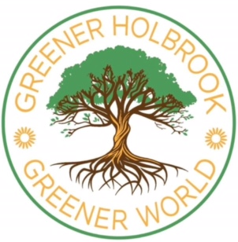
GREENER HOLBROOK GREENER WORLD
If you're thinking of buying some new clothes for the summer please consider buying pre-loved/re-used clothes. Not only does this support the many charities which sell pre-loved/re-used clothing, it's much better for our environment.
Clothing is being produced and discarded at an ever increasing pace. Fashions and trends are rapidly changed, directed by business and marketing models to ever increase sales and profits without any regard for the overuse and rampant waste of our Earth's resources.
All of this over production of clothes uses vast amounts of water and creates vast amounts of pollution, including microscopic plastic fibres and many chemicals harmful to human health and the environment. Tiny fibres from synthetic clothing materials, such as polyester, acrylic and nylon (and many more) don't degrade naturally in the environment. When we wash or wear these materials the microscopic fibres are shed into the water system and the air. These have been found in our rivers, oceans, rain, snow, ice, air, soil, worms, shellfish, fish, birds, animals, eggs, fruit and vegetables, and human bodies.
A bin lorry load of clothing is sent to landfill or incinerated every second, much of it never worn or hardly worn (http://news.un.org/en/story/2025/03/1161636). That's 92 million tons of clothes discarded every year (and increasing). It's said that we already have enough clothes on Earth to clothe the next six generations.
So a great way to help local charity shops and our environment is to have a look for clothing items you need in a local charity shop instead of a fast fashion outlet or online fast fashion trader. You can also find helpful videos and ideas for how to repair/alter your clothing on the internet or at our local repair cafe.

