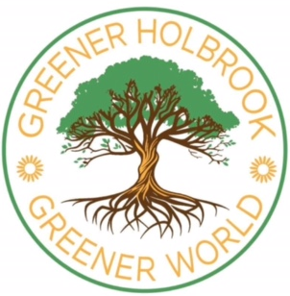
Living in Holbrook, trying to recycle our plastics in our blue bins and at soft plastic recycling points, we could be forgiven for not realising plastic is still a real problem. We don't see the mountains of plastic waste and plastic containing used clothing dumped in developing countries. 69% of clothing is partially or entirely synthetic, made of plastics such as polyester. These synthetic materials shed tiny fibres of plastic into the water and air.
Plastic pollution is a massive problem worldwide. Currently we produce 430 million tonnes of new plastic a year, with 60% of this destined for single-use and only 9% recycled worldwide (https://www.worldwildlife.org/pages/global-plastics-treaty). At current rates, production is set to double by 2050. Plastic waste, micro plastics (minute plastic particles) and chemicals from plastic products have been found everywhere on Earth. In our oceans, rivers, rain, ice, air, soil, plants, fish, worms, eggs, animals, human lungs, human blood and human fetuses. There is increasing evidence that these microplastics and chemicals from plastic products can have serious negative effects on our health, and cancer causing effects, when they build up in our bodies over time.
If we imagine the Earth is a bath, and plastic production and waste are running taps, we're trying to prevent the bath overflowing by bailing out (recycling) with a teaspoon. Which is probably why nearly 3 million people, 103 countries, and 175 nations agree we need to unite and decide on a Global Plastics Treaty to curb the problem. It's hoped that this treaty will steer food and clothing manufacturers in particular towards circular economy principles. Using plastics and making products which can be readily reused and recycled. Creating more return and refill schemes and stopping unnecessary single-use plastics.
While the big companies and governments work on this we can keep trying to do our bit to help. We can make sure we don't leave plastic litter in our gardens and countryside. Plastic litter can persist in the environment and end up as tiny plastic particles in our rivers and soil. We can try to buy food products with less plastic packaging and try to buy sustainable clothing. For more information on how to help please see the Earth Day 2025 website (earth day.org). Earth Day is on Tuesday 22nd April 2025.

