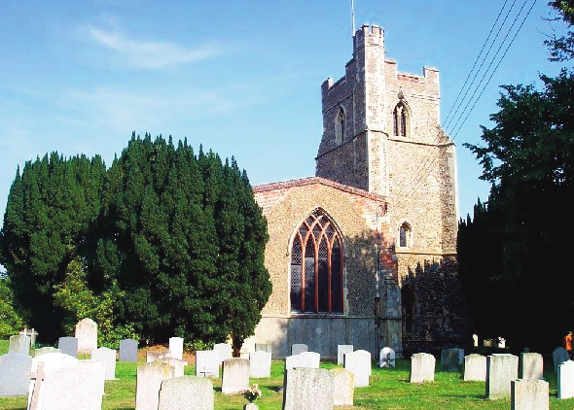

**H**

**O**

**L**

**B**

**R**

**O**

**O**

**K**

**C**

**O**

**M**

**M**

**U**

**N**

**I**

**T**

**Y**

**E**

**M**

**E**

**R**

**G**

**E**

**N**

**C**

**Y**

**P**

**L**

**A**

**N**

**I**

**s**

**s**

**u**

**e**

**9**

**2**

**0**

**2**

**3**

**T**

**h**

**i**

**s**

**p**

**l**

**a**

**n**

**h**

**a**

**s**

**b**

**e**

**e**

**n**

**a**

**u**

**t**

**h**

**o**

**r**

**i**

**s**

**e**

**d**

**b**

**y**

**t**

**h**

**e**

**u**

**n**

**d**

**e**

**r**

**s**

**i**

**g**

**n**

**e**

**d**

**o**

**n**

**b**

**e**

**h**

**a**

**l**

**f**

**o**

**f**

**H**

**O**

**L**

**B**

**R**

**O**

**O**

**K**

**P**

**a**

**r**

**i**

**s**

**h**

**C**

**o**

**u**

**n**

**c**

**i**

**l**

**COMMUNITY EMERGENCY PLAN**

Name of Community:

**HOLBROOK IPSWICH SUFFOLK**

**Emergency Community Co-ordinator:**

**Primarily - JOHN AMBROSE**

Date of issue:

**June 2023**

*(To be reviewed anually or as necessary).*

**Distribution of plan:**

Holbrook Parish Council web-site www.holbrook.onesuffolk.net

Freddie Gulliver – Emergency Planning Office

|  |  |  |
| --- | --- | --- |
| **Document History** | | |
| **Issue No.** | **Date** | **Change/s** |
| Draft | Jan. 2009 | Initial document |
| Issue 1 | June 2009 | Various items updated |
| Issue 2 | June 2010 | New issue |
| Issue 3 | July 2011 | New issue |
| Issue 4 | July 2012 | New issue |
| Issue 5 | June 2013 | New issue and additional information included |
| Issue 6 | Sept 2015 | New issue |
| Issue 7 | Dec 2016 | New issue |
| Issue 8 | June 2020 | New issue updated information |
| Issue 9 | June 2023 | New issue |

**COMMUNITY EMERGENCY**

**RESPONSE PLAN**

**Contents**

**4**

**5**

**6**

**7**

**7/8**

**9**

**10**

**10/11**

**12**

**13**

**14**

**15**

**16**

**17**

**18**

**19**

**20**

**20**

**21**

**Aims and Objectives.......................................................**

**Effects on the community..............................................**

**Risk Analysis Matrix......................................................**

**Emergency Centre...........................................................**

**Roles...................................................................................**

**Communications..............................................................**

**Parish Council Contacts.................................................**

**Local Resourses.. .............................................................**

**Contacts.............................................................................**

**Runners’ Zones................................................................**

**Emergency Centre Equipment Box .............................**

**List of Vulnerable People..............................................**

**Log Sheet...........................................................................**

**Geographical Map of the Community........................**

**Action to be taken...........................................................**

**Action Check List............................................................**

**Community Emergency Meeting.................................**

**Opening Emergency Centre .........................................**

**Closing Emergency Centre / Debrief...........................**

**Aim and Objectives**

**Aim of the Plan:**

**To increase short-term community resilience.**

**Objectives of the plan:**

1. **Identify vulnerable elements of the community**
2. **Identify hazards and possible mitigation measures**
3. **Identify resources and key contacts in the community**

**Role for the Parish Council:**

**Organising and co-ordinating volunteers**

**Emergency Co-ordinator:**

A person living locally who provides a vital link between the community and other organisations, planning and responding to an emergency.

Their rôle is to:-

1. Undertake the completion and maintenance of the community Emergency Plan
2. Provide a link to the District Emergency Planning Officer
3. Call a community meeting during an emergency (if deemed necessary)
4. Provide the focal point for the community response to an emergency

**Ways that the community can be affected:**

**An emergency can cause:-**

* **Death or injury of people**
* **Loss or damage to:**

**Homes, businesses, community buildings**

**Road, rail or air transport networks**

**Electricity. Telephone or water supplies**

**Supply of goods and services**

* **Isolation**
* **Large scale media focus**

**The local community in the form of the Parish Council may be involved in a number of ways:**

* **As first responders**
* **Providing support to the emergency organisations**
* **Voicing community wishes**
* **Providing input to community recovery**

**RISK ANALYSIS**

|  |  |  |  |  |
| --- | --- | --- | --- | --- |
| **Hazard** | **Impact** | **Mitigation in Place** | **Mitigation Possible** | **Risk Matrix Score** |
| **Flooding** | **Loss of access Loss of utilities.**  **Homes/business.** | **Volunteer ground force.**  **Vunerable people check & support.** | **Monitor Flood warnings.**  **Sandbags.** | **B** |
| **Total or partial loss of electricity** | **Care homes.**  **Business.**  **Vulnerable people.** | **Generators.**  **Public advice info.**  **Torches & candles.**  **Vulnerable people** | **List of vulnerable people.** | **A** |
| **Total or partial loss of water** | **Care homes.**  **Business.**  **Vulnerable people.** | **Vulnerable people.**  **Public advice info.**  **Supply back-up** | **List of vulnerable people.** | **A** |
| **Total or partial loss of telephone** | **Care homes.**  **Business.**  **Vulnerable people.** | **Vulnerable people.**  **Voluntary message delivery teams.** | **List of vulnerable people.** | **A** |
| **Severe weather** | **Damage to property.**  **Tree damage.**  **Vulnerable people.**  **Casualties.** | **Volunteer force on stanby.**  **Emergency access.**  **Contact out of hours-Surgery** | **List of vulnerable people.**  **Chainsaws.**  **Lifting gear.**  **Surgery** | **A** |
| **Major fire** | **Loss of access.**  **Business and buildings.**  **Casualties.** | **Local retained Fire Station.** | **Doctors’ surgery.** | **A** |
| **Loss of road access** | **Services.**  **Vulnerable people.** | **Alternative. routes.**  **(Communicat ewith AW)** | **Alternative .route maps.** | **C** |

**Risk Matrix Score: A = High Likelihood and High Impact**

**B = Low Likelihood and High Impact**

**C = High Likelihood and Low Impact**

**D = Low Likelihood and Low Impact**

**EMERGENCY AND EVACUATION CENTRE**

**Location and Address:-**

**Holbrook Village Hall**

**The Street,**

**Holbrook**

**Ipswich**

|  |  |  |
| --- | --- | --- |
| **Key Holder(s)** | **Address** | **Telephone** |
| **D. Rose** | **14 Mill Rise.** | **01473 328862** |
| **C.Ambrose** | **32 Clifton Wood** | **01473 328815** |

Keys are also kept at the Co-operative Store.

**EMERGENCY CENTRE ROLES \***

|  |  |  |  |
| --- | --- | --- | --- |
| **Role** | **Name** | **Telephone** | **Alternative** |
| **Response Coordinator** | **XXXXXX** | **XXXXXX** |  |
| **Centre Manager** | **XXXXXX** | **XXXXXX** |  |
| **Log Keeper** | **XXXXXX** | **XXXXXX** |  |
| **Comms Clerk** | **XXXXXX** | **XXXXXX** |  |
| **Comms Clerk** | **XXXXXX** | **XXXXXX** |  |

* These rôles will be allotted at the time it is decided to open the Emergency Centre (see Page 21).

Also required are volunteers to act as runners to inform the community of the situation. These should be available from, both, the parish councillors and members of the village hall committee.

**Insurance**

Volunteers are covered under thr Holbrook Parish Council insurance except for personal equipment and clothing. These need to be covered under their own insurance (e.g. Home insurance).

Response Coordinator

The Response Coordinator is responsible for the local response, by taking a tactical overview of the incident and making judgements based on the information available. The Response Coordinator should continuously monitor the situation, make tactical and operational decisions as required, and guide personnel. If possible the Response Coordinator is to liaise regularly with the emergency services, informing them of the situation, obtaining a strategic briefing and, in turn, providing an update briefing for the rest of the Emergency Centre personnel.

If the Response Coordinator is to leave the Emergency Centre, for any reason, they must arrange for a deputy to be fully briefed before taking over.

Centre Manager

The Centre Manager is in charge of the management of the Centre itself. This includes the smooth flow of information; the availability and serviceability of communications equipment and other facilities in the Centre. As well as general administration, duties also include the general welfare of the staff working in the Centre, such as refreshment, shift change and rest facilities.

The Centre Manager should not leave the Emergency Centre without first informing the Response Coordinator.

Communications Clerks

The Communications Clerks’ task is to receive and send messages by telephone or any other means of communication available in the Centre. They are to relay all messages to the Response Coordinator and the Centre Manager and ensure that a record of each message is passed to the Log Keeper.

Log Keeper

The Log Keeper is responsible for accurately recording both outgoing and incoming messages and the actions taken. These records are to be kept in a suitable “log”, which should contain concise records of pertinent points and actions and is to be completed in full.

**COMMUNICATIONS**

|  |  |
| --- | --- |
| **System** | **Comments** |
| **Emergency Contact Numbers** | **01473 328815/07715 002620 - John Ambrose**  **01473 327663/07853007280– Mrs Jo Hazlewood** |
| **Cascade ‘phone System** | **See page 18** |
| **Notice Boards** | Village Hall, Co-operative Store, Corner of Heathfield Road and the Street.  Abbotts Way, Marsh Gate Car Park Lower Holbrook.  Social media.  Church and Methodist Chuch notice boards. |

**PARISH COUNCIL MEMBERS**

|  |  |  |
| --- | --- | --- |
| **J. Ambrose** | **01473 328815**  **07715 002620** | **Chairman** |
| **R. Allinson** | **07464 485738** | **Vice Chairman** |
| **G. Abbott** | **07880 721193** |  |
| **R. Connick** | **07555342519** |  |
| **S. Ingleton** | **07711 108230** |  |
| **M. Holmes** | **01473 808054** |  |
| **A. King** | **07867870442** |  |
| **D. Martin** | **01473 326908** |  |
| **M. Pittman** | **07580 513020** |  |
| **A. Wright** | **07769 708969** |  |
| **Mrs. J. Hazlewood** | **01473 327663** | **Clerk** |

**COMMUNITY RESOURCES**

|  |  |
| --- | --- |
| **RESOURCE** | **CONTACT** |
| **Retained Fire Staion** | **Via 999** |
| **Doctors Surgery** | **01473 328263** |
| **Co-operative Store** | **01473 328214** |
| **Woody’s** | **01473 327835** |
| **Local farms machinery** | **See Specialist Equipment –Page 11** |
| **Village Hall** | **01473 328862** |
| **The Swan PH** | **01473 328401** |
| **Police:**  Capel | **01473 383115** |
| Martlesham | **01473 613500** |
| **Holbrook Helpers** | **0333 335 5387** |
| **All Saints Parish Church** |  |
| Rev.Jenny Seggar | **01473 327951 07733 195866** |
| **Methodist Church** |  |
| C/o Gerald Laws | **01473 328507** |

**SPECIALIST EQUIPMENT**

|  |  |
| --- | --- |
| **Contact** | **Contact Details** |
| Richard Abbott | **01473 328017** |
| SCH Supplies | **01473 328800** |
| Royal Hospital School | **01473 326200** |
| Local Farms | **Various** |

**OTHER RELEVANT CONTACTS**

|  |  |
| --- | --- |
| **Contact** | **Contact Details** |
| Steve Henthorn (Babergh Mid Suffolk C.C.) | **01284 758460/07920 46634** |
| Above contacts during office hours | **01473 433444** |
| ACS – (Adult Care Services) * | **0808 917 1109** |
| Anglian Water | **0345714**  **Report leaks: 0800 771881** |
| BBC Radio Suffolk | **01473 250000**  **News desk: 01473 340707** |
| CYP - (Children & Young People) * | **8080 800 4005** |
| Deputy Co-ordinator | **01473 XXXX** |
| Emergency Co-ordinator | **01473 XXXXX** |
| Emergency Services | **999** |
| Environment Agency Floodline | **0345 988 1188** |
| Gas | **0800 111 999** |
| Holbrook Academy | **01473 328317** |
| Holbrook Helpers | **0333 335 5387** |
| Holbrook Surgery | **01473 328263**  **Emergencies: 111** |
| Local Police | **01473 613500** |
| NHS Direct | **111 (18001 111 textline)** |
| Orwell Veterinary Group | **01473 333677-Kesgrave** |
| Press ? |  |
| Primary School | **01473 328225** |
| Royal Hospital School | **01473 326200** |
| J.Cartlidge MP South Suffolk | **01787 212353** |
| Suffolk CC Highways | **0345 606 6171** |
| Suffolk County Council | **0345 606 6067**  **(Safety and Community)** |
| Suffolk Fire and Rescue Service | **01473 260588** |
| Suffolk Police HQ | **01473 613500** |
| UK Power Network - East England | **080078308838** |

**\*** = Out of Hours 01473 433444

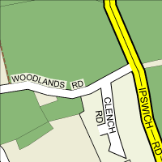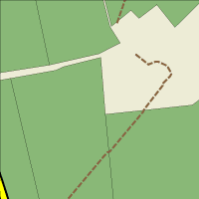

**Zone 1**

**Zone 2**

**Zone 3**

**Zone 4**

**Zone 5**

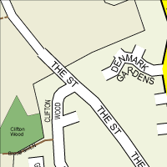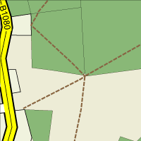

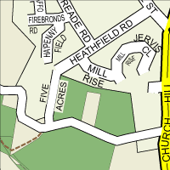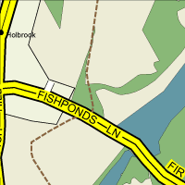

**Zone 6 – Covers Fishpond Lane to Lower Holbrook**

**This map indicates the proposed zones for ‘runners’ to warn and inform the community of an emergency.**

###### EMERGENCY CENTRE EQUIPMENT

***Suggested items***

**Emergency Centre Box**

Copies of all plans

Incident Log Book

Emergency Centre Signs

Wind-up radio

Lamp & Batteries

Powerful torch (Rechargeable)

High visibility waistcoats

Foil Blankets

Water

First Aid Kit

Generator

***Lists:***

Electoral roll (copy)

Vulnerable people list-confer with churches and local groups

Volunteers

Skills

Equipment

***Paperwork***:

Evacuation Register

Unaccompanied minors register

Volunteer register

Equipment register

***Individual Document Packs***

A4 lined pad

Ball point pens (blue/green/red)

Information lists:

Contact names & numbers are in plan.

**VULNERABLE PEOPLE**

|  |  |  |
| --- | --- | --- |
| **Name** | **Address** | **Assistance Reqd.** |
|  |  |  |
|  |  |  |
|  |  |  |
|  |  |  |
|  |  |  |
|  |  |  |
|  |  |  |
|  |  |  |
|  |  |  |
|  |  |  |
|  |  |  |
|  |  |  |
|  |  |  |
|  |  |  |
|  |  |  |
|  |  |  |
|  |  |  |
|  |  |  |
|  |  |  |
|  |  |  |

**Due to individual confidentiality and changing circumstances, names of vulnerable people will be collated from ‘on the ground’ personal knowledge of parishioners** **at the time of the incident.**

**LOG SHEET *(Example Only)***

|  |  |  |  |
| --- | --- | --- | --- |
| **Date** | **Time** | **Info/Actions/Decisions** | **Initials** |
|  |  |  |  |
|  |  |  |  |
|  |  |  |  |
|  |  |  |  |
|  |  |  |  |
|  |  |  |  |
|  |  |  |  |
|  |  |  |  |
|  |  |  |  |
|  |  |  |  |
|  |  |  |  |
|  |  |  |  |
|  |  |  |  |
|  |  |  |  |
|  |  |  |  |
|  |  |  |  |
|  |  |  |  |
|  |  |  |  |
|  |  |  |  |
|  |  |  |  |
|  |  |  |  |
|  |  |  |  |
|  |  |  |  |
|  |  |  |  |
|  |  |  |  |
|  |  |  |  |
|  |  |  |  |
|  |  |  |  |

**GEOGRAPHICAL MAP OF COMMUNITY**

Village Hall

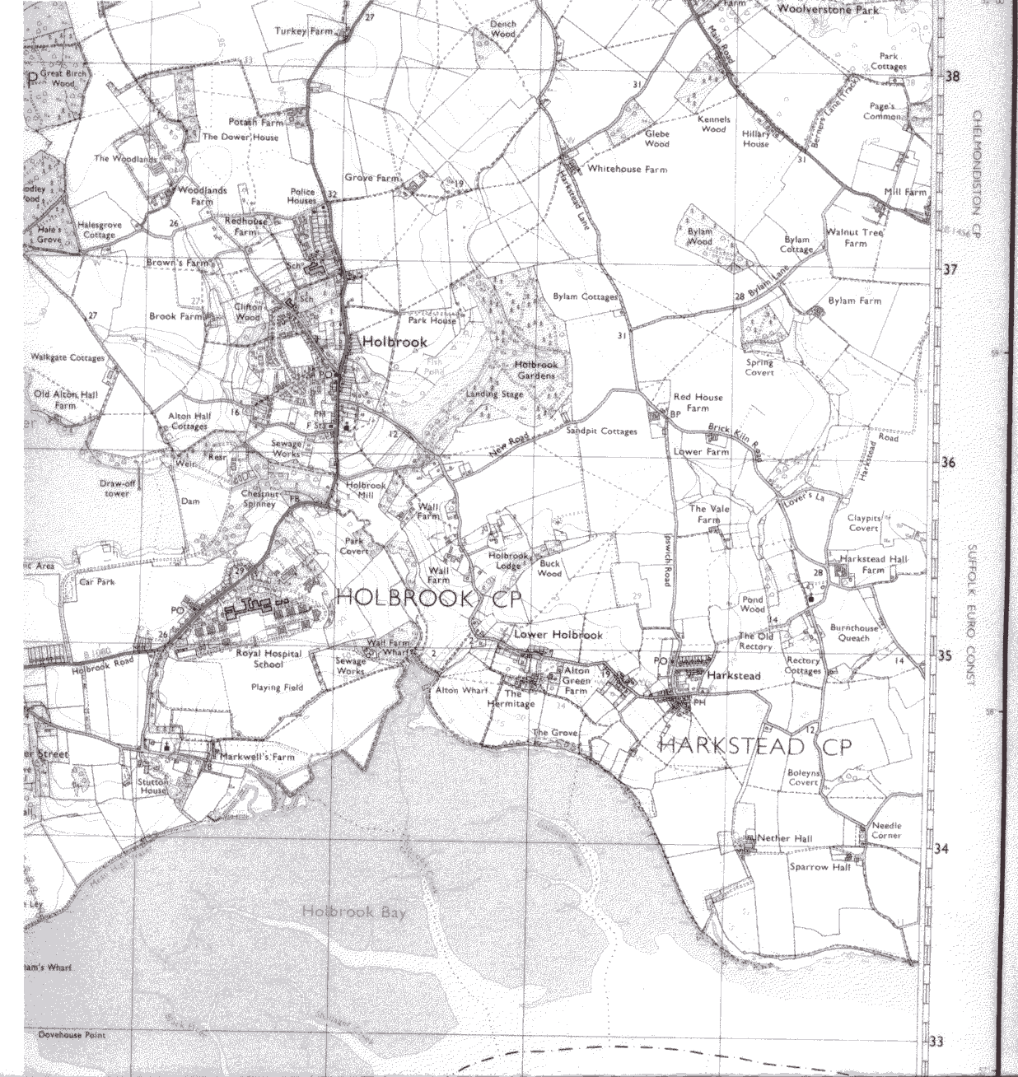

**NOTE: Lower Holbrook, due to it’s geographical position, is also covered by the emergency plans of Harkstead Parish Council whose help and cooperation should be sought.**

**ACTION TO BE TAKEN**

**Activation and Call out**

**Plans will be activated following, or in anticipation of, an emergency. The decision to activate the plan is to be made by either the Community Emergency Officer, any member of the Community Emergency Team, Parish Council, or any person authorised to do so by any of the aforementioned. As soon as the decision to activate the plan has been made, follow the actions as outlined in the Action Check List (Page 20).**

* **It is vital that, in the event of an emergency situation affecting all or part of the community, the initial action is to telephone 999. Follow instructions given by the emergency services or local authority supported by information included in this plan. If contact with Police, Fire and Rescue Service and Ambulance Service NHS Trust is not possible or the response is likely to be substantially delayed the Community Emergency Plan should be used to assist the local response until help arrives.**
* **In an emergency the emergency services want clear, concise information as soon as possible. Try to use the time available awaiting their response to obtain further information and if there is any additional information telephone the emergency services again to update them, as this might affect the resources they deploy.**
* **Until help arrives and without endangering yourself or other local people contact the appropriate members of the community listed in the plan and ask them to report to the agreed assembly point, (See table below for cascade process).**
* **When the emergency services or local authority are on scene try to make contact with them and explain who you are and what your role is.**
* **The Emergency Co-ordinator should keep the District Council informed.**
* **Ensure records are kept of all communications and decisions made.**

**Call Out Cascade Process**

**Two people should be nominated as main contact points in the case of an emergency. These people should then contact other council members as set out below.**

**The current emergency contacts are: John Ambrose 01473 328815/07715 002620**

**Mrs Jo Hazlewood 01473 327663**

|  |  |
| --- | --- |
| Robert Allinson | Melanie Holmes |
| Gerald Abbott | Alec Wright |
| Denise Martin | Max Pittman |
| Andrew King | Sally Ingleton |
| Rick Connick |  |
|  |  |

**EMERGENCY ACTION CHECK LIST**

**Activation and Call out**

|  |  |
| --- | --- |
| * **Dial 999 ensure the emergency services are aware of the emergency and follow any advice given.** * **Contact the District Council.** * **Use log sheet to record:-**   ***Any decisions made and reasons.***  ***Who you spoke to and what was said.***   * **Contact relevant people that need to be alerted:-**   ***Those specifically under threat***  ***Key holders and volunteers***  ***Council members***  **Contact initially may be to inform them of the current Emergency Service advice regarding any action to be taken** |  |
|  |  |

**Community Emergency Meeting**

* **Is a meeting necessary?**
* **Is the venue safe to hold the meeting and can people get there safely?**
* **Has the District Council been informed that you are**

**Holding a Community Emergency Meeting?**

* **Has the community been informed there will**

**be a meeting?**

* **Take a copy of the first agenda to the meeting**

**Under no circumstances should you put yourself at risk to fulfil these tasks Community Emergency Meeting**

**The Emergency Co-ordinator should consider a Village Emergency Meeting, to include the widest possible audience, at the earlist opportunity to discuss the emergency.**

**The safety of both the meeting site and access to the site should be considered when choosing the meeting location. Detailed minutes should be taken. Below is only a guide and more items should be added to accurately meet the needs of the emergency.**

1. **Briefing on the current situation, if possible Emergency Services or the District Emergency Planning Officer should undertake this briefing.**
2. **Immediate actions to aid the response to the emergency.**
3. **Actions required in the future to aid community recovery.**
4. **Time and date of next meeting.**

Opening the Emergency Centre

The decision to open the Emergency Centre lies with the Community Emergency Officer, any member of the Community Emergency Team, Parish Council, or any person authorised to do so by any of the aforementioned. Once the decision is made:

* the authorised person should inform the key holder and nominate personnel to fill the posts within the Centre (see Page 9);
* the Emergency Centre Box (see Page 14) is to be acquired, opened at the Centre and its contents distributed as appropriate;
* start the Incident Log with the appropriate data;
* turn on the radio and listen for relevant broadcasts;
* set up the room;
* set up Emergency Centre sign/s at the entrance/s;
* Inform the emergency services and/or the District/Borough Council in accordance with the current agreement.

Once the Centre is functional there should be a member of the Community Emergency Team in the Centre throughout the emergency who will provide advice and guidance as required.

**Closing the Emergency Centre**

The Emergency Centre should remain open for as long as the incident continues and / or community personnel are involved with any community response activity and there is no other facility open to coordinate their actions.

When the decision is made to close the Emergency Centre the Centre Manager and staff should adopt a set procedure to ensure that no important documents go astray. All documents, messages, logs and forms are to be gathered up and, as far as possible, grouped together logically and kept in a secure place. If possible, a digital camera should be used to record any information displayed on boards and maps. These images can be stored for reference at a later date. The Emergency Centre Manager will ensure that all resources are returned to their owners or placed in safe keeping for recovery later. The Response Coordinator is to inform all agencies and organisations that were informed when the Emergency Centre was opened and record the closing down actions taken.

**Debrief**

All exercises and incidents must be debriefed so that lessons can be learnt. If weaknesses are found, the relevant corrective measures taken. Personnel involved should attend a “Hot” debrief with the Response Coordinator or the Centre Manager immediately after the incident has closed, or at the end of their shift. Details of the debrief will be recorded and kept with all the other documents for use when collating material for the main debrief to be held at a later date. (Some exercises will not need to be accompanied by a second debrief.)

**This plan has been authorised by the undersigned on behalf of HOLBROOK Parish Council.**

Name: John Ambrose

Authority/Role: Chairman - Holbrook Parish Council

Signature:...................................................................

***Issue 9 Please destroy all previous issues***