Asset and Responsibility Register
HOLBROOK PARISH COUNCIL

Author: Jo Hazlewood
Clerk to Holbrook Parish Council
Updated March 26 v. 14
Contents

1. INTRODUCTION
2. LIST OF ASSETS AND VALUES
3. RESPONSIBILITIES
APPENDIX 1: MAP OF HOLBROOK
APPENDIX 2: PICTURES OF ASSETS (omitted in email version)

Introduction
This document contains details of all Assets and Responsibilities held by Holbrook Parish Council as at 31st March 2026.

It is acknowledged that some of the valuation figures have been arrived at through best endeavours using the information known to us at the time.

This document will be reviewed by the Council at least annually. Assets will be entered, adjusted or removed as and when appropriate.

Jo Hazlewood
Parish Clerk

Version 14 adopted at Parish Council Meeting on 16th March 2026

Signed:

Jo Hazlewood Cllr John Ambrose
Parish Clerk Chairman

Assets *Key: PP = purchase price
Index | Description | No. | Location | Date of acquisition | Total value | Basis of valuation* | Insured Value
1 | Village Sign | 1 | Church Green | 1977 | £ 290.00 | Historic | £ 500.00
2 | Bus shelters | 2 | O/S The Compasses PH, Woodlands Road junction Ipswich Road |  | £ 1,452.00 | Historic | £ 7,000.00
3 | Teak benches | 2 | Church Green, Alton Green | Jun-06 | £ 1,131.00 | PP | £ 581.00
4 | War memorial | 1 | Church Green |  | £ 726.00 | Historic | £ 726.00
5 | Dog bins | 11 | Various | from pre-2004 onwards | £ 718.00 | Historic | £ 0
6 | Waste bins | 19 | Various | from pre-2004 onwards | £ 2,160.00 | Historic  Replacement  Cost | £ 0
7 | Noticeboard | 1 | Lower Holbrook Marsh Gate | Aug-06 | £ 223.00 | PP | £ 300.00
8 | Noticeboard | 1 | Heathfield Road junction The Street | Mar-05 | £ 278.00 | PP | £ 300.00
9 | Footpath map in display case | 1 | Outside Co-op, The Street |  | £ 350.00 | historic | £ 350.00
10 | Grit bins | 7 | Heathfield Road junction The Street – Corner Clifton Wood/The Street, Heathfield Road/Reade Road, Halpenny Field, Jervis Close/Mill Rise, Berners Field, Heathfield Road/Five Acres | Oct-03 & Feb 22 | £ 95.00 | PP | £ 665.00
11 | All weather surface | 1 | Reade Field | Mar-08 | Removed |  | £ 0
12 | Balance weave | 1 | Reade Field | Mar-08 | £ 465.00 | PP | £ 465.00
13 | Basket ball court surface | 1 | Reade Field – replaced April 2025 | Apr-25 | £ 9862.00 | PP | 0
14 | Basket ball posts | 2 | Reade Field | Jul-08 | £ 7,710.00 | PP | £ 2,800.00
15 | Climber frame Lighthouse (yellow) | 1 | Reade Field |  | Removed |  | £ 0
16 | Climber frame Look out (red) | 1 | Reade Field |  | Removed |  | £ 0
17 | Climber frame Spaceship (green) | 1 | Reade Field |  | Removed |  | £ 0
18 | Swing junior 1 bay 2 seat (near to wildflower area) | 1 | Reade Field |  | £ 1,500.00 | Historic | £ 3,500.00
19 | Swing toddler 1 bay 2 seat (on playground) | 1 | Reade Field |  | £ 1,646.00 | Historic | £ 3,500.00
20 | Wobble board – spring beam and stepping stones | 1 | Reade Field | Mar-08 | £ 220.00 | PP | £ 220.00
21 | Goal posts metal 5 a side | 2 | Reade Field |  | Removed | PP | £ 0
22 | Log traverse, suspended with bollards (swinging logs) | 1 | Reade Field | Mar-08 | Removed | PP | £ 0
23 | Multiplay toddler (small slide) | 1 | Reade Field | Apr-15 | £ 4,716.00 | PP | £ 4,716.00
24 | Roller balance beam with rope (Rocknroll log) | 1 | Reade Field | Mar-08 | £ 720.00 | PP | £ 720.00
25 | Slide – embankment – platform (big slide) | 1 | Reade Field | Mar-08 | Removed | PP | £ 0
26 | Tram tracks (Rope walk) | 1 | Reade Field | Mar-08 | £ 570.00 | PP | £ 570.00
27 | Trapeze rings with bollards (trapeze swing) | 1 | Reade Field | Mar-08 | £ 730.00 | PP | £ 730.00
28 | Goalposts – full size | 2 | Reade Field | June 22 | £ 1.359.00 | PP | £ 1.359.00
29 | Log benches | 7 | Reade Field: 5 adjacent to play area, 1 Enchantress entrance, 1 wild area |  | £ 109.00 | Historic | £ 0
30 | Pavilion building | 1 | Reade Field | May-03 | £ 29,929.00 | Replacement | £ 60,000.00
31 | Pavilion contents | Misc | Reade Field Pavilion: |  | £ 500.00 | Insured | £ 560.00
32 | Strimmer | 1 | P3 Group | July 24 | £ 500.00 | PP | £ 492.00
33 | DR Trimmer | 1 | P3 Group |  | £ 500.00 | PP | £ 424.00
34 | Shed | 1 | Ipswich Road,, storage of P3 equipment | Nov-18 | £ 376.00 | Replacement | 0
35 | Filing cabinet | 1 | Clerk's home address |  | £ 30.00 | PP | £ 0
36 | Phone Box | 1 | Clench Road, Holbrook |  | £ 1.00 | PP | £ 0
37 | Clerks Laptop | 1 | Replacement laptop | May-22 | £ 374.00 |  | £ 374.00
38 | Swarco Speeding Sign | 1 | Fitted to 5 separate locations in village | Jan-19 | £ 2811.00 | PP | £ 2811.00
39 | HP Envy Pro 6432 Printer | 1 | Clerk's Home address | Sep-20 | Disposed of | PP | £ 0
40 | Children’s Roundabout | 1 | Reade Field Children’s Playground | Feb 21 | £ 3,751.00 | PP | £ 3,751.00
41 | Exercise Bike | 1 | Reade Field, adjacent to Playground | Feb 21 | £ 989.00 | PP | £ 990.00
42 | Sky Stepper | 1 | Reade Field, adjacent to Playground | Feb 21 | £ 1,194.00 | PP | £ 1,194.00
43 | Table Tennis Table | 1 | Reade Field – rear of The Swan garden | Feb 21 | £ 2,245.00 | PP | £ 2,245.00
44 | Aerial Swing | 1 | Reade Field, in front of basket ball court | Feb 21 | £ 6,831.00 | PP | £ 6,831.00
45 | Picnic benches | 2 | 1 near children’s play area. 1 between aerial swing & table tennis table | Feb 21 | £ 917.00  each | PP | £ 1,834.00
46 | Dble pulldown challenger | 1 | Reade Field, adjacent to Playground | Feb 21 | £ 2,035.00 | PP | £ 2,035.00
47 | Rower | 1 | Reade Field, adjacent to Playground | Feb 21 | £ 1,285.00 | PP | £ 1,285.00
48 | New Gate | 1 | Reade Field Entrane, The Street end | Feb 21 | £ 1,364.00 | PP | £ 1,364.00
49 | Noticeboard | 1 | Admirals Quarter | Feb 21 | £ 369.00 | PP | £ 370.00
49a | Noticeboard | 1 | Noticeboard Reade Road/Reade Field | May 25 | £ 0.00 | N/A | £ 0
 | All Weather safety surface |  | Reade Field play area, and equipment | Feb 21 | £ 17,833.00 | Pp | £ 0
50 | 5-a-side goal posts and fixings | 2 | Reade Field | July 21 | £ 780.00 | Pp | £ 780.00
51 | Circular picnic table | 1 | Reade Field | Aug 21 | £ 1.317.00 | Pp | £ 1,318.00
52 | Heavy duty picnic table | 2 | Reade Field | Aug 21 | £ 867.00 | Pp | £ 1,734.00
53 | Junior Picnic table | 1 | Play area Reade Field | Aug 21 | £ 951.00 | Pp | £ 951.00
54 | Park Bench | 1 | Ipswich Road (opp. Gants Cottage) | Aug 21 | £ 549.00 | Pp | £ 550.00
55 | Bench seat | 1 | Alton Green | Aug 21 | £ 431.00 | Pp | £ 432.00
56 | Column, Bracket & lights of street lighting | 31 | Numerous – see schedule | historic | £ 12,400.00 | Replacement | £ 3,000.00
57 | Gate from Reade Rd to Field | 1 | From Reade Rd to Reade Field | historic | £ 2,500.00 | Replacement | £ 2,500.00
58 | Reade Field signs re dogs | 3 | Both ends Reade Field and 1 on playpark | Nov 22 | £ 245.00 | Pp | £ 0
59 | Optical Camera | 1 | With Hedgehog Management Group | Feb 23 | £ 101.00 | Pp | £ 0
60 | Signs for Hedgehogs | 6 | Various signs for hedgehog highway | Feb 23 | £ 277.00 | Pp | £ 0
61 | Accessible Gate | 1 | From Reade Road to Reade Field | Oct 23 | £ 1,364.00 | Pp | £ 1,364.00
62 | Defibrillator | 1 | Adjacent to noticeboard Abbotts Way | Sept 23 | £ 2,820.00 | Pp | £ 2,820.00
63 | New slide complex | 1 | On Reade Field | June 24 | £ 11,776.00 | Pp | £ 11,776.00
64 | New log traverse | 1 | Children’s Play Park Reade Field | June 24 | £ 3,125.00 | Pp | £ 39,125.00
65 | Stag Beetle Information sign | 1 | Hapenny Field | Feb 26 | £ 190.00 | PP | £ 190.00
 |  |  |  | TOTAL | £ 147,531.00 | TOTAL | £ 144,393.00
Assets (less pavilion and contents) Insured through Community Action Suffolk, Policy No. ACY 2427916 £560.29, Excess varies from £100 - £250
Pavilion and contents separately insured through CAS, Ansvar Insurance Policy No. 7192344 to be renewed 01.04.26 Total Assets, without pavilion and contents: £83,833.00

Responsibilities

Holbrook Parish Council is responsible for three areas of land within the parish boundary.
  - The Reade Field, between Reade Road and The Street, is leased from the Greenwich Hospital Estates (The Royal Hospital School) for an annual peppercorn rent of one Suffolk reed. The lease began on 15th July 1968 and runs for 99 years. The reed is usually presented to the Headmaster of the RHS at the Annual Parish Meeting. The land management company is Strutt and Parker, who are consulted on issues arising and significant changes, new equipment and so on. There are covenants within the lease for the maintenance of the Reade Field and its facilities.
  - Church Green, a small area of grass in front of All Saints Church on Church Hill, is registered common land. This is maintained by the Parish Council who look after the village sign, war memorial, bench, dog and litter bins and grass cutting.
  - Alton Green, an area of uncultivated land in Lower Holbrook, is registered common land and contains a pond which is maintained by the Parish Council, and 2 benches which are insured by the Council but one is maintained by the family who installed it in memory of their relations.
Both Alton Green and Church Green are subject to the protection of the Local Authority (Holbrook Parish Council) under section 9 of the Commons Registration Act 1965. Section 9 states that “…any local authority in whose area the land or part of the land is situated may take such steps for the protection of the land against unlawful interference as could be taken by an owner in possession of the land, and may (without prejudice to any power exercisable apart from this section) institute proceedings for any offence committed in respect of the land.”
Number | Description | Details | Date
1 | Grass cutting of main Reade Field. | Contract in place with Vertas to cut grass. | Billed quarterly
2 | Cutting edges of Reade Field | Strim field edges, around play equipment and Millennium area paths | Approx. 6 times per year
3 | Maintenance of Clifton Road side of boundary of Reade Field | Hedge cutting as required. | As and when
4 | Maintenance of War Memorial |  | As and when
5 | Maintenance of Church Green | Grass cutting | 8 times per year
6 | Maintenance of Alton Green | Grass cutting in line with conservation advice | Approx. 2 times per year
7 | Maintenance of Alton Green pond | Clearance in line with conservation advice | As and when

Appendix 1: Map of Holbrook

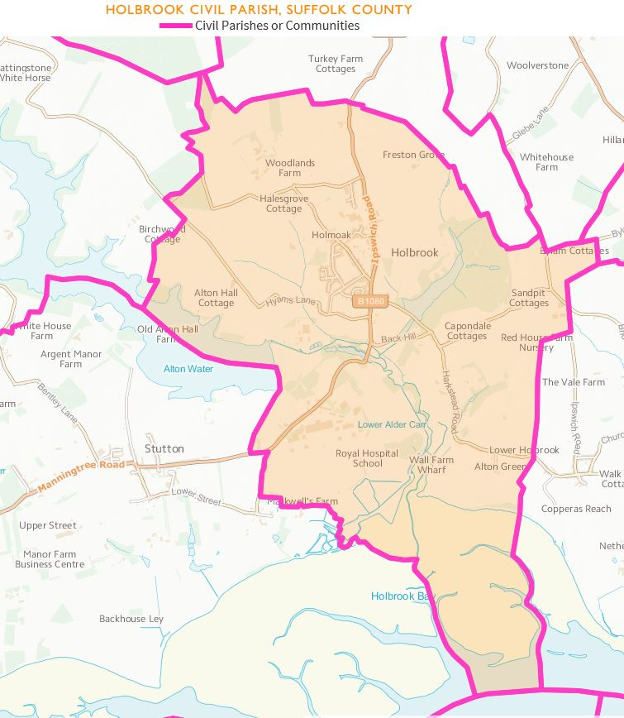

Appendix 2: Photo Inventory Assets

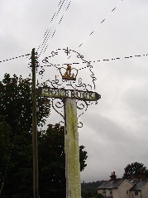 | 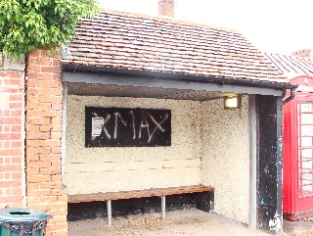 | 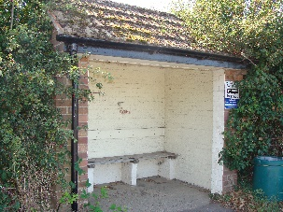 | 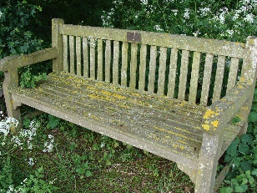 | 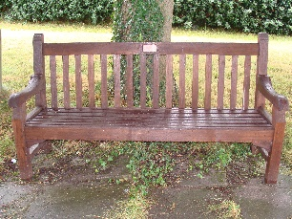 | 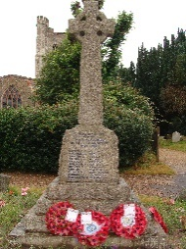 | 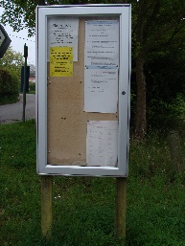
1 Village Sign | 2 Bus shelter o/s Compasses PH | 2 Bus Shelter at Woodlands Road | 3 Bench at Alton Green | 3 Bench at Church Green | 4 War memorial | 7 Noticeboard Lower Holbrook
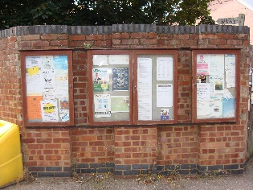 | 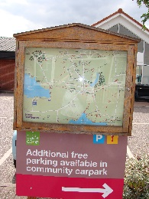 |  | 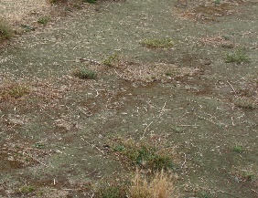 | 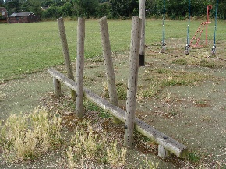 | 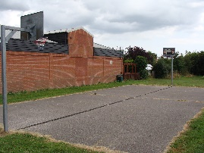 | 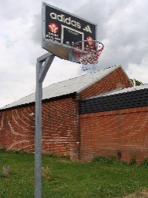
8 Noticeboard Heathfield Road junction | 9 Footpath map outside Co-op | 10 Grit Bin | 11 All Weather Surface | 12 Balance Weave | 13 Basketball court surface | 14 Basketball posts
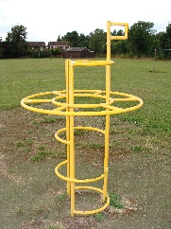 | 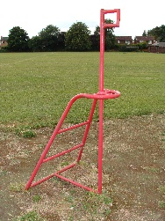 | 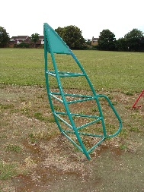 | 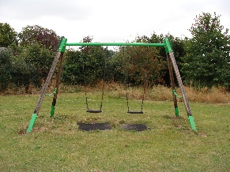 | 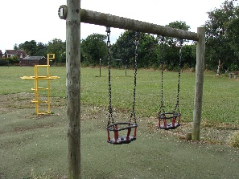  Figure 1Asset 19 - Dog Bin  Figure 2Asset 19 - Dog Bin  Figure 3Asset 19 - Dog Bin | 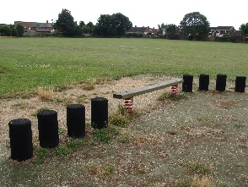 | 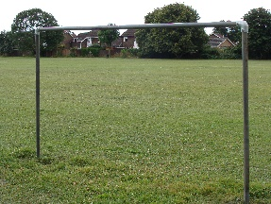
15 Climber frame lighthouse removed | 16 Climber frame look out removed | 17 Climber frame spaceship removed | 18 Swing junior 1 bay 2 seat | 19 Swing toddler 1 bay 2 seat | 20 Spring beam and stepping stones | 21 Goal posts, metal 5 a side

 | 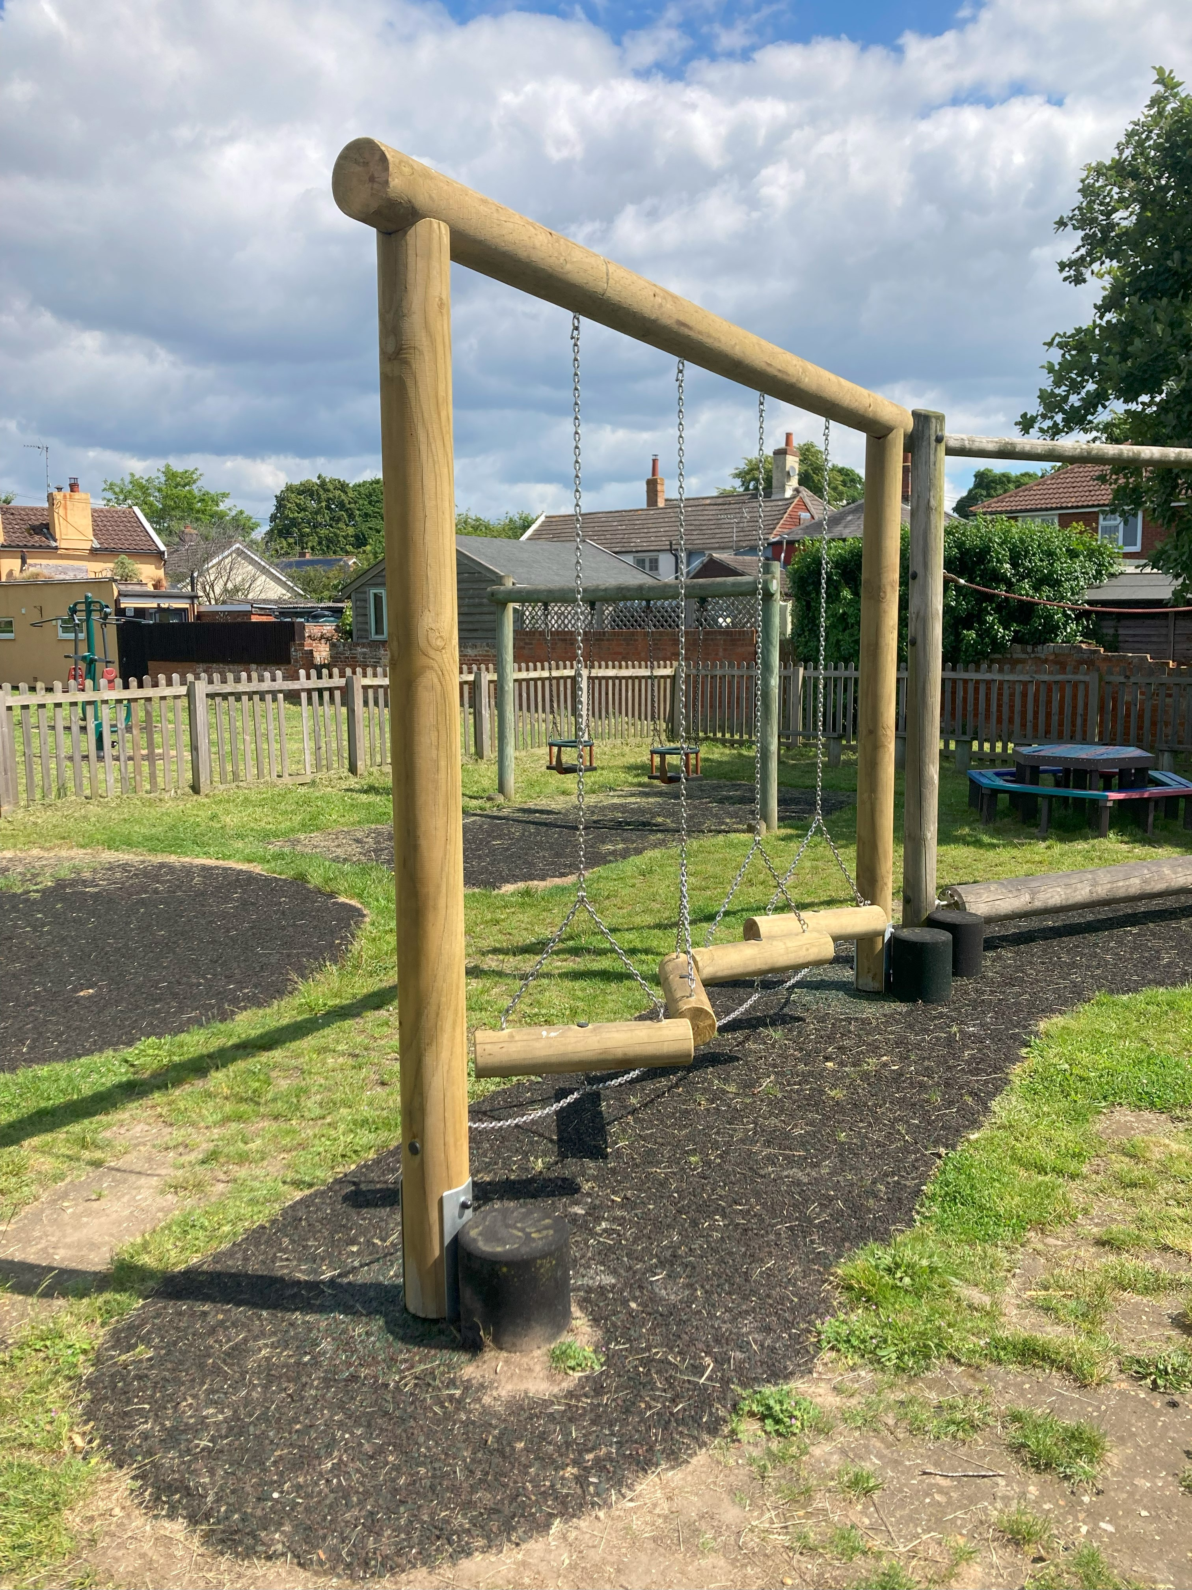 |  | 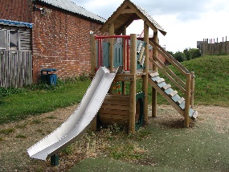 |  | 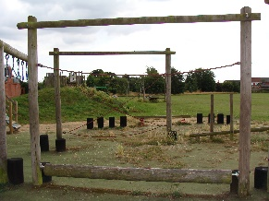 | 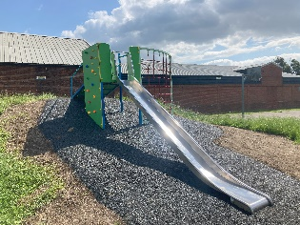 | 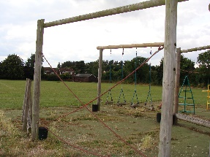 |  |  | 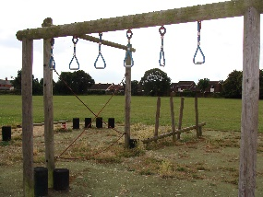 |  | 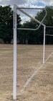
 | 64 Log traverse with bollards |  | 23 Multi play toddler |  | 24 Roller balance beam | 63 Slide, embankment and platform | 26 Rope walk |  |  | 27 Trapeze rings with bollards |  | 28. Full Size goalposts
 | 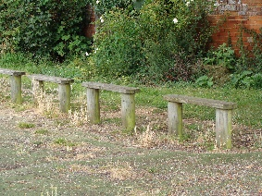 |  | 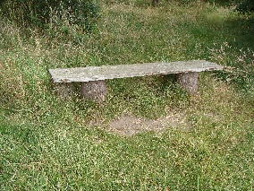 |  | 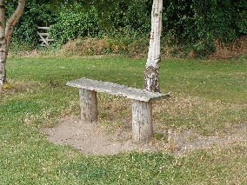 | 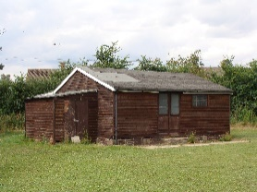 |  |  |  | 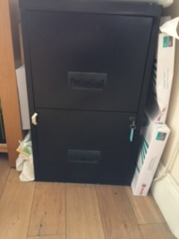 |  | 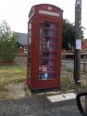
 | 29 Log benches at play area |  | 29 Log bench wildflower area |  | 29 Log bench, Enchantress gate | 30 Pavilion – Reade Field | 34 P3 Shed |  |  | 35 Filing Cabinet – Clerk’s House |  | 36 Phone Box Clench Road
 | 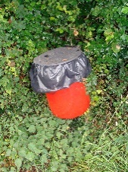 |  | 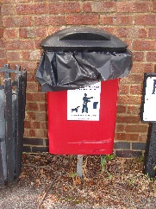 |  | 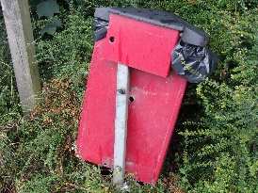 | 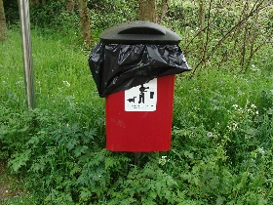 | 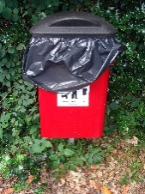 |  |  | 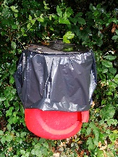 |  | 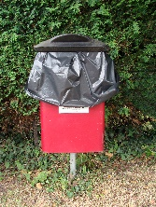
 | 5 Dog bin Five Acres Hyams Lane end |  | 5 Dog bin Heathfield Road opposite surgery |  | 5 Dog bin Ipswich Road footpath entrance Garland Cottage | 5 Dog bin Harkstead Road Lower Holbrook Car Park | 5 Dog bin Petticoat Lane at Denmark Gardens footpath entrance |  |  | 5 Dog bin Ipswich Road entrance to the Cut |  | 5 Dog bin Village Hall Car Park
 | 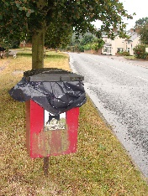 |  | 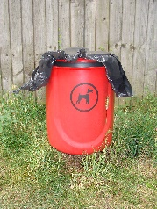 |  | 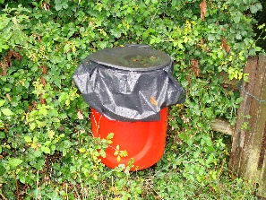
 | 5 Dog bin Church Green |  | 5 Dog bin Clifton Wood rear of Reade Field |  | 5 Dog bin Fishponds Hill at footpath 23 entrance
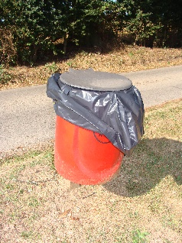 |  | 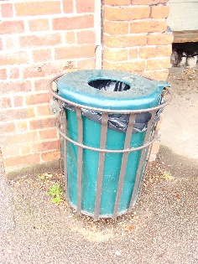 |  | 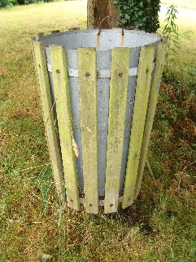 |  | 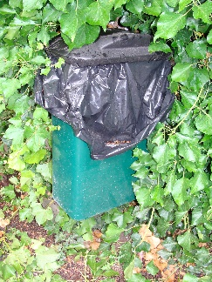 |  | 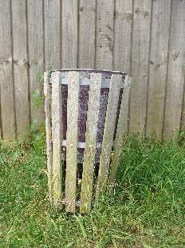 | 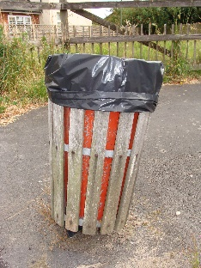 |  | 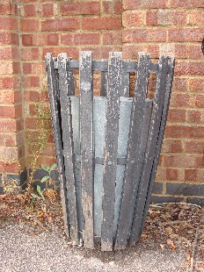
5 Dog bin Woodlands Road  layby next to St Marys |  | 6 Litter bin Ipswich Road by bus shelter at Compasses Inn |  | 6 Litter bin Church Green opposite Hyams Lane |  | 6 Litter bin Church Hill opposite the Mill |  | 6 Litter bin Clifton Wood rear of Reade Field | 6 Litter bin Heathfield Road layby opposite Rosenheath |  | 6 Litter bin Heathfield  Road opposite Surgery
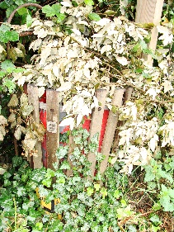 |  | 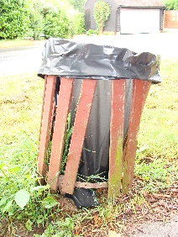 |  | 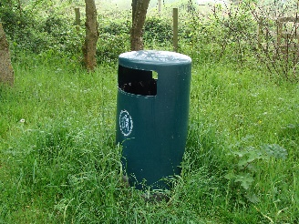 |  | 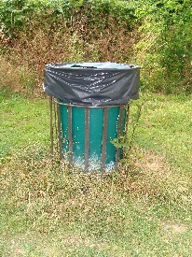 |  | 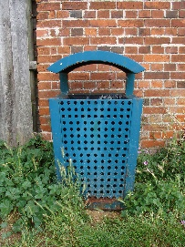 | 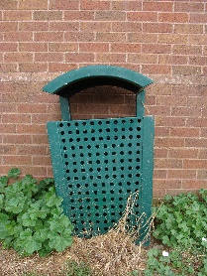 |  | 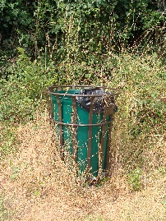
6 Litter bin Ipswich Road  end of the Cut |  | 6 Litter bin Ipswich Road opposite Gants Cottage |  | 6 Litter bin Lower Holbrook Car Park |  | 6 Litter bin Reade Field behind 18 Reade Road |  | 6 Litter bin Reade Field rear of play area | 6 Litter bin Reade Field rear of the Co-op |  | 6 Litter bin Reade Field  rear of the Pavilion
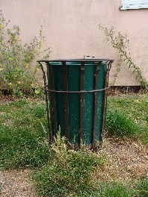 |  | 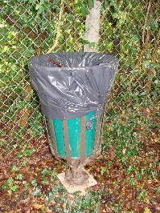 |  | 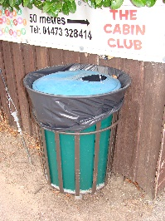 |  | 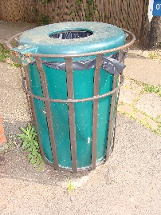 |  | 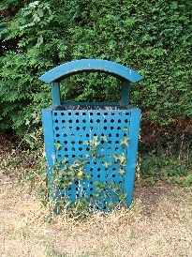 | 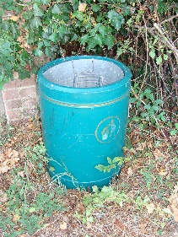 |  | 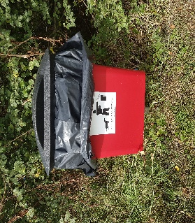
6 Litter bin Reade Field  rear of Enchantress |  | 6 Litter bin The Cut by the Academy rear gates |  | 6 Litter bin The Street near the Primary School |  | 6 Litter bin The Street near to East Row |  | 6 Litter bin Village Hall Car Park | 6 Litter bin Woodlands Road bus shelter |  | 6 Dog Bin at top of  Alton Green
 |  | 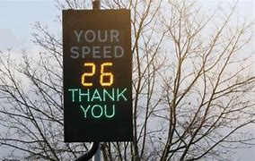 |  | 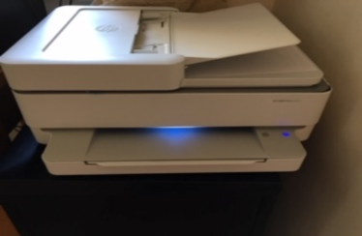 |  | 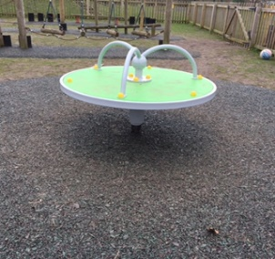 |  | 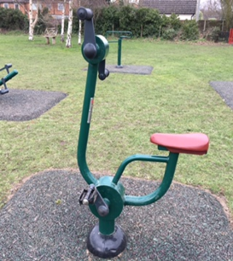 | 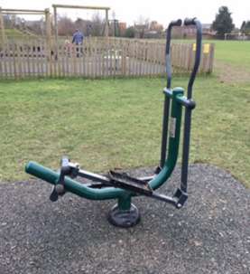 |  | 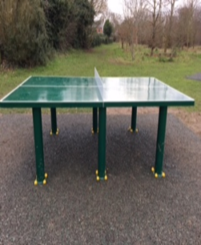
37 Clerks Laptop –  Clerk’s house |  | 38 Speeding Sign – various positions |  | 39 HP Envy Printer – Clerk’s house |  | 40 New roundabout  Reade Field Play Area |  | 41 Pedal Cycle  Reade Field | 42 Sky Stepper - Reade Field |  | 43 Table Tennis table  Reade Field
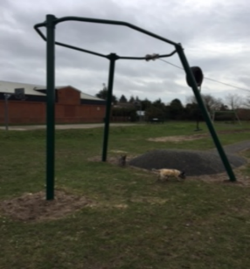 |  | 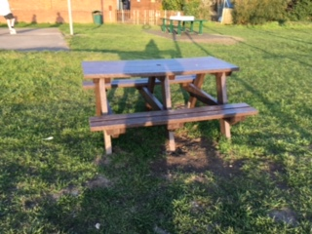 |  | 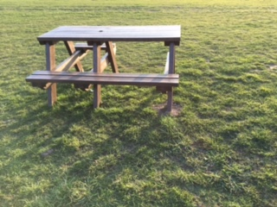 |  | 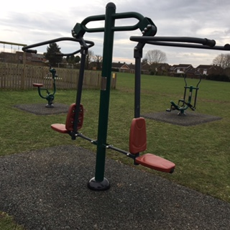 |  | 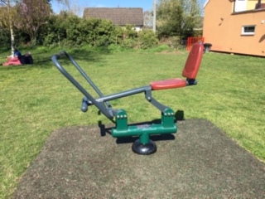 | 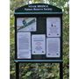 |  | 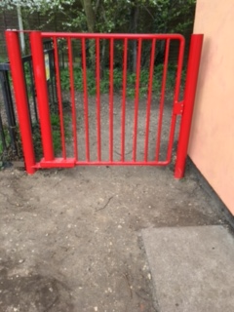
44 New zip wire  Reade Field |  | 45 Picnic Bench |  | 45 Picnic Bench |  | 46 Double Pull Down Challenger |  | 47 Rower | 48 Noticeboard Admirals Quarter |  | 49. New entrance gate  to Reade Field
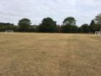 |  | 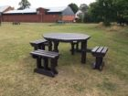 |  | 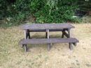 |  | 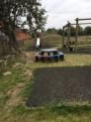 |  | 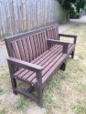 | 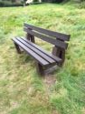 |  | 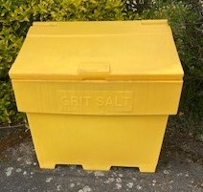
50. 5-a-side goalposts  Reade Field |  | 51. Circular bench Reade Field |  | 52 Heavy duty picnic table (2) both on Reade Field |  | 53 Junior Picnic table  Play Area Reade Field |  | 54 Park Bench –  Ipswich Road | 55 Bodmin Bench seat – Alton Green |  | 10 New grit bins (5)
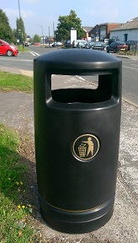 |  | 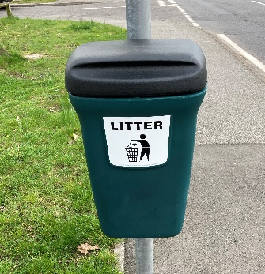 |  | 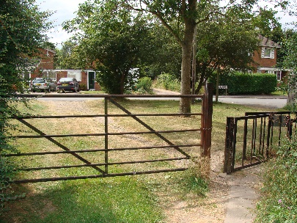 |  | 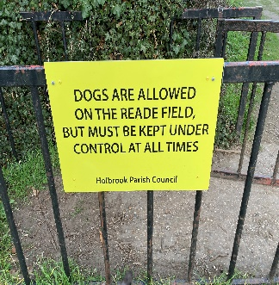 |  | 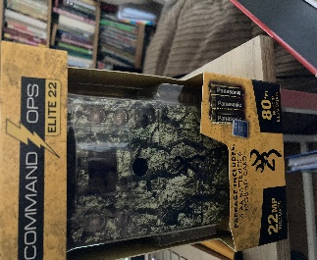 | 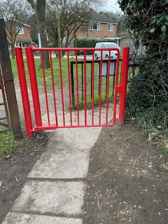 |  | 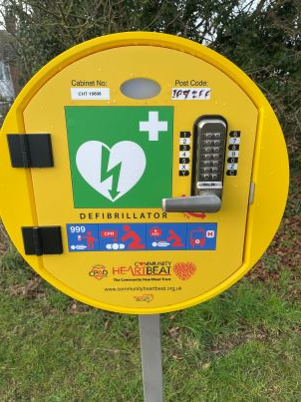
6 New litter bins (2) |  | 6 New bin by bus stop |  | 57 Gate from Reade Rd |  | 58 Signs for Reade Field |  | 59.Optical camera | 61 New Accessible gate |  | 62. Defibrillator
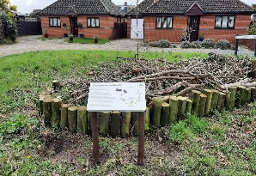

65 Stag Beetle Info sign
.

Appendix 3: Pictures of Responsibilities
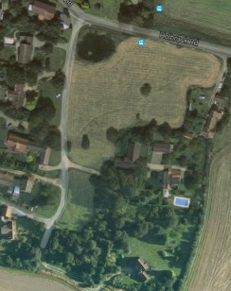 | 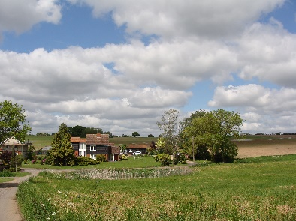 | 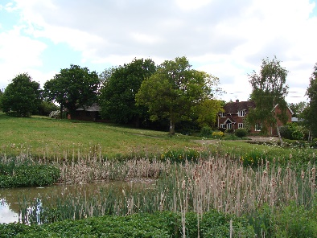 | 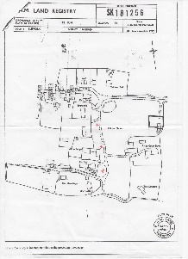
Alton Green aerial view | Alton Green | Alton Green pond | Alton Green mature trees for which HPC are responsible.
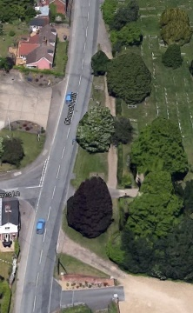 | 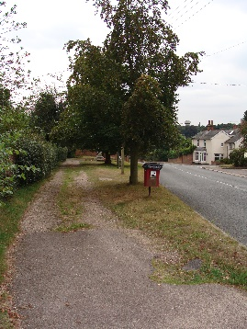 | 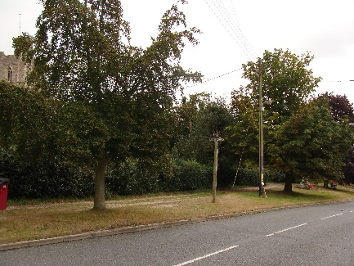 | 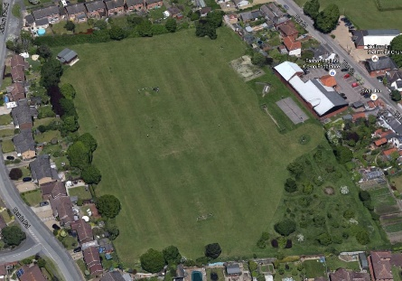
Church Green aerial view | Church Green | Church Green | Reade Field aerial view
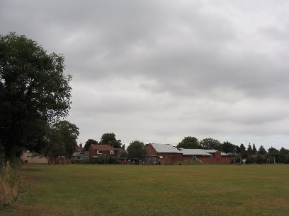 | 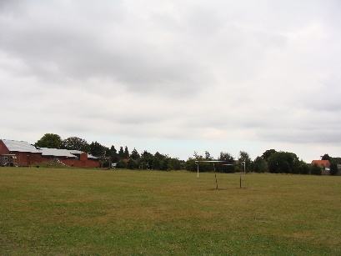
Reade Field | Reade Field | Reade Field, The Street entrance | Reade Field, Reade Road entrance

