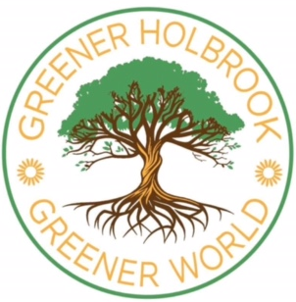
This Halloween, I'd love to encourage you to try to go a little more sustainable. In our very busy modern lives it's easy to just grab Halloween decorations, sweets and costumes from Supermarkets, but these decorations and costumes are mostly plastic, and most sweets are plastic wrapped. Every year in the UK, it's estimated that 7 million Halloween costumes are thrown away, and 2,000 tons of plastic waste is created. Micro plastics are a serious pollutant in the environment and in our own bodies. This kind of waste and 'throw away culture', without reuse or recycling, uses up the Earth's resources at a far faster rate than the Earth can replenish (so it's not sustainable).
If you start thinking of ideas for decorations and/costumes early, you'll hopefully have a bit of time to gather together natural items, or items you can reuse or recycle. For example, maybe you could find an old sheet for a ghost (cut small holes to see through and paint larger black eyes around the holes) or a black fluffy jumper for a bat costume, with black recycled material from a charity shop to make wings.
Maybe you could plan a walk to collect colourful autumn leaves, conkers or old twigs to make decorations. Old twigs can make spiders legs with black painted cardboard bodies, or put twigs in a vase and hang cut out cardboard spiders or bats on the twigs.
Try using recycled cardboard cut from cereal boxes or other packaging. Recycled card can also be used to make silhouettes of cats, bats, owls, moons and stars, or spiders to stick to your window. Then hang an old sheet over the silhouettes in your window with your curtains open. From the outside the light inside your house will glow through the old sheet, showing up the silhouettes. You could make cardboard 'day of the dead' style masks, painted with bright coloured designs and decorated with tissue paper flowers.
Pumpkins are more sustainable, if instead of just carving them and throwing away the flesh and seeds, you use them to make soups or meals, or toast the seeds to make snacks. CBBC has some good ideas at: bbc.co.uk/news round/50241354.
Sweets wrapped in foil are more sustainable because aluminium foil can be easily recycled. Just collect up and squash together small foil wrapping pieces into a ball about the size of a tennis ball and put it into your blue bin.

There are lots of sustainable Halloween ideas online, some are more sustainable than others. Trying not to buy new plastic decorations and costumes, and trying reuse or recycle where possible is a great way to enjoy Halloween with less harm to our World (www.worldwildlife.org/pages/10-greener-halloween-tips).

